Who is an authentic jew? In a facebook post a day or so ago, jack love wrote about this question in biblical times, postulating the weakness in ascribing the term to jesus, long before the rabbinical period. A debate ensued, following jack’s statement: “Most of you have probably looked at a map of the Roman Empire at some point, and most of those maps bear a legend that reads, "The Roman Empire at its greatest extent, reign of Trajan." Trajan ruled from 98 to 117 and the Empire extended from England to North Africa and from Spain to Iraq. Included within those borders was a vast number of people who worshiped the Israelite God. We commonly refer to these folks as "Jews" although that term is an anachronism, there really weren't any Jews until about two hundred years later--the more correct term IMO is "Judeans." In part, that answers the question, "Was Jesus a Jew?" Correct answer: "No." If the Christian Bible has it right, then he was a Galilean who honored the God of Israel and followed some version of the Hebrew Bible which clearly differed from what would become Judaism. But I digress.”

Leap forward two thousand years to Africa, where one of the leading anthropologists, peter geschiere, wrote about the new hot topic, indigeneity. Why hot? Because the structural adjustment programs laid on Africa in the 1980s meant that national govts were no longer really in charge of their lands and resources, and as foreign companies and govts gained “free trade” neo-liberal access to African resources, conditions for economic marketing depended on the World Bank’s approval. That meant national entities that used to dictate prices and ownership of things like forests began to revert to local communities. In Cameroon, the indigenous people of a given community were to receive a percentage of the profits of the lumber from their forests, so that it became important to be able to prove you were indeed indigenous to the village, even if you had long since migrated to the city. For political reasons, the govt decided to define indigeneity as based on where your fathers were buried. Ancestors. Paternal and sacrosanct to many people, but often buried in locations not necessarily in the village where you came from; and even if your father came from there, what of his father and his?

Adonoi Avraham, adonoi yizhak, adonoi ya’akov, what we learned when I was young in Hebrew school. But where was Abraham from, and where was his father buried. Come to think of it, what about where jesus was buried? And if you are modern and add sarah, rivkah, Rachel, and leah, well, where were their fathers from, and where did Rachel wind up in the soil?

A wandering jew, children of wandering parents, 400 years in Egypt, or children of exile. Children of diaspora, of flight into Egypt, into the shtetls, across Europe and across the waters to England or Sweden or the united states. Children of the lower east side, of Cleveland and Detroit and Chicago. where are you from. and if you want a passport to Israel to go home, who decides who you are, where your grandparents’ bones remain? No longer Russia, for me; they were actually in kiev or Odessa, Ukraine now.

We are children of the sea, according to Wikipedia, which posts this image in response to the question, where is the jewish homeland: 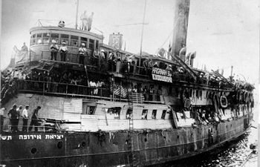

We are then people of the exodus, not of the aleiya, not the return, which is always temporary. Home is gone, remade anew, and then eventually abandoned as the kids grow up and leave the nest. The house grows old. We retire, and content ourselves with zoom calls. And remember what it was like when we look at the old photos of when we were young.

The answer to what makes us jews, from this parshah, lies in a cave, described this way by Jacob.
29And he commanded them and said to them, "I will be brought in to my people; bury me with my fathers, in the cave that is in the field of Ephron the Hittite,
30in the cave that is in the field of Machpelah, which is before Mamre in the land of Canaan, which field Abraham bought from Ephron the Hittite for burial property.
31There they buried Abraham and his wife Sarah, there they buried Isaac and his wife Rebecca, and there I buried Leah.
32The purchase of the field and the cave therein was from the sons of Heth."
33And Jacob concluded commanding his sons, and he drew his legs [up] into the bed, and expired and was brought in to his people.

And joseph who followed his example said,

24Joseph said to his brothers, "I am going to die; God will surely remember you and take you up out of this land to the land that He swore to Abraham, to Isaac, and to Jacob."
25And Joseph adjured the children of Israel, saying, "God will surely remember you, and you shall take up my bones out of here."
26And Joseph died at the age of one hundred ten years, and they embalmed him and he was placed into the coffin in Egypt.

In today’s news I read the betanyahu welcomed Jonathan pollard, who spent 30 years in jail for spying for Israel, by greeting him with the words, welcome home. Here is the image of the cave of Machpelah, according to the artist’s, or Wikipedia’s, imaginary. Here is home, if you are jewish. It certainly is not the Bronx:
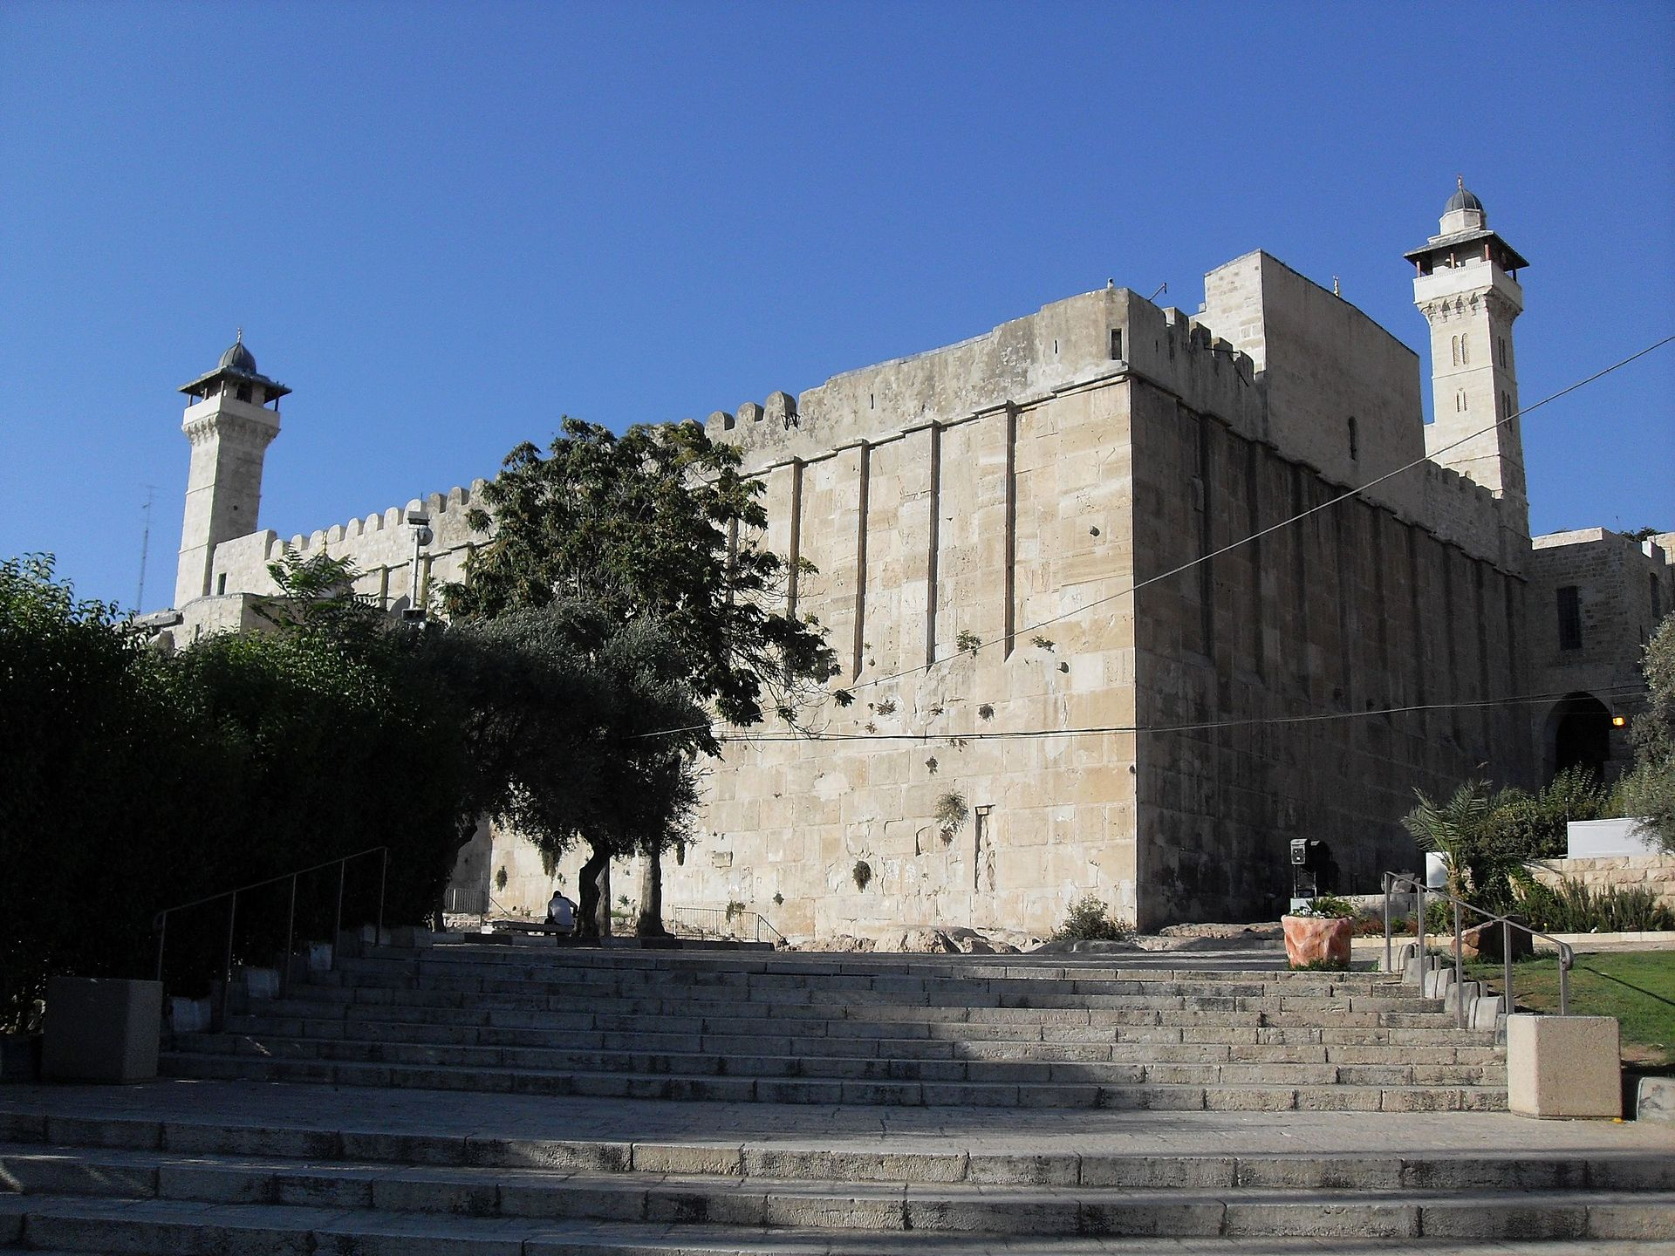
Hebron, cave of the patriarchs

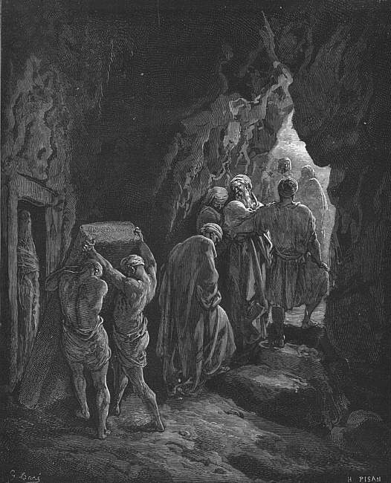
Woodcut by Gustave Doré depicting the burial of Sarah in the cave
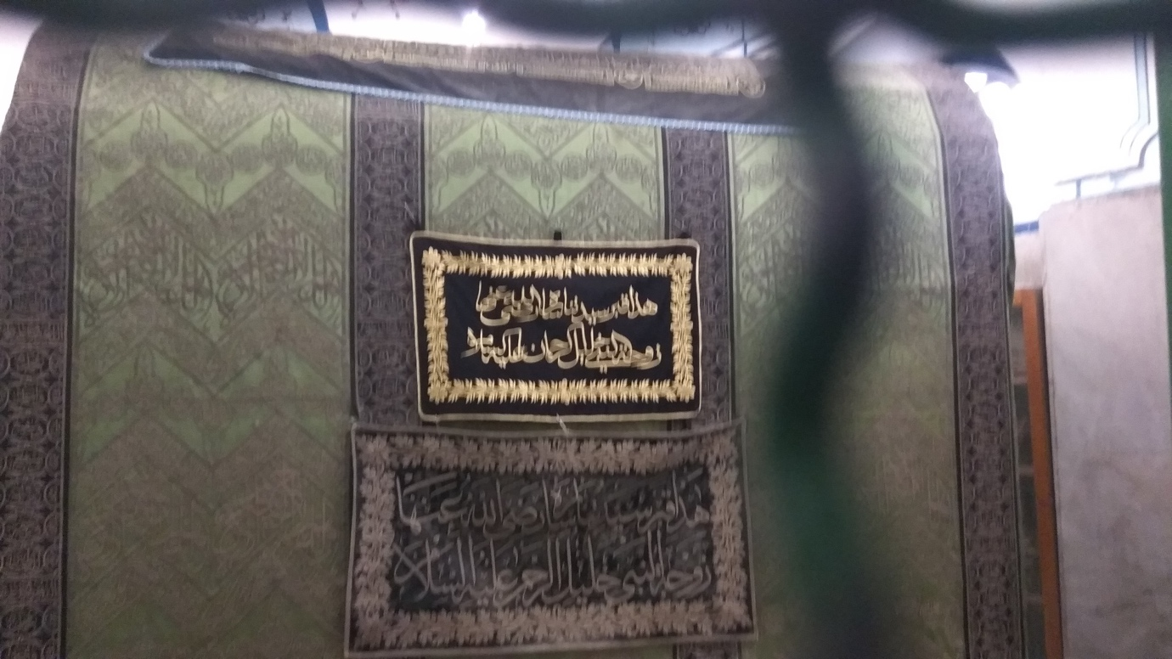
Tomb of sarah in the mosque
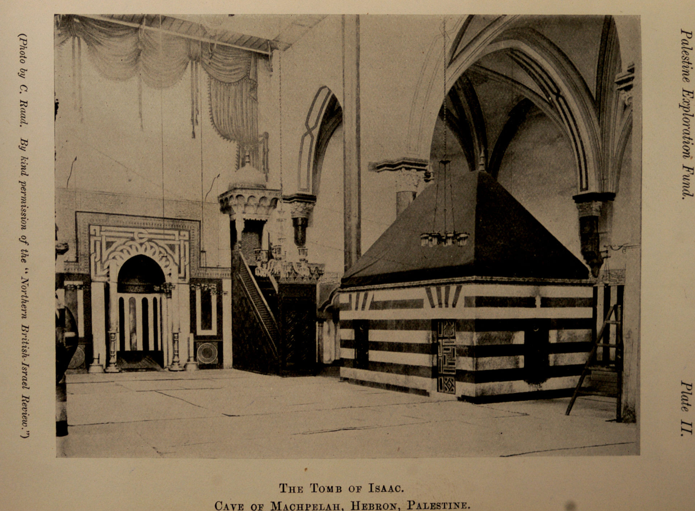

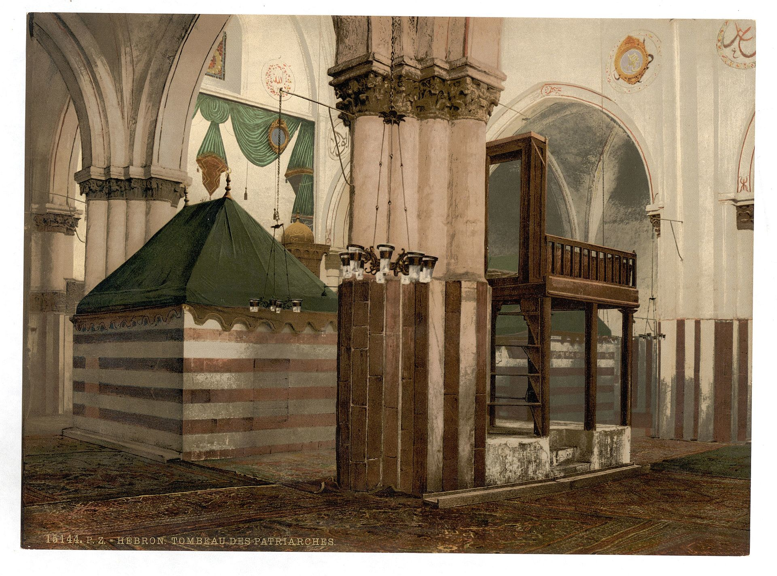
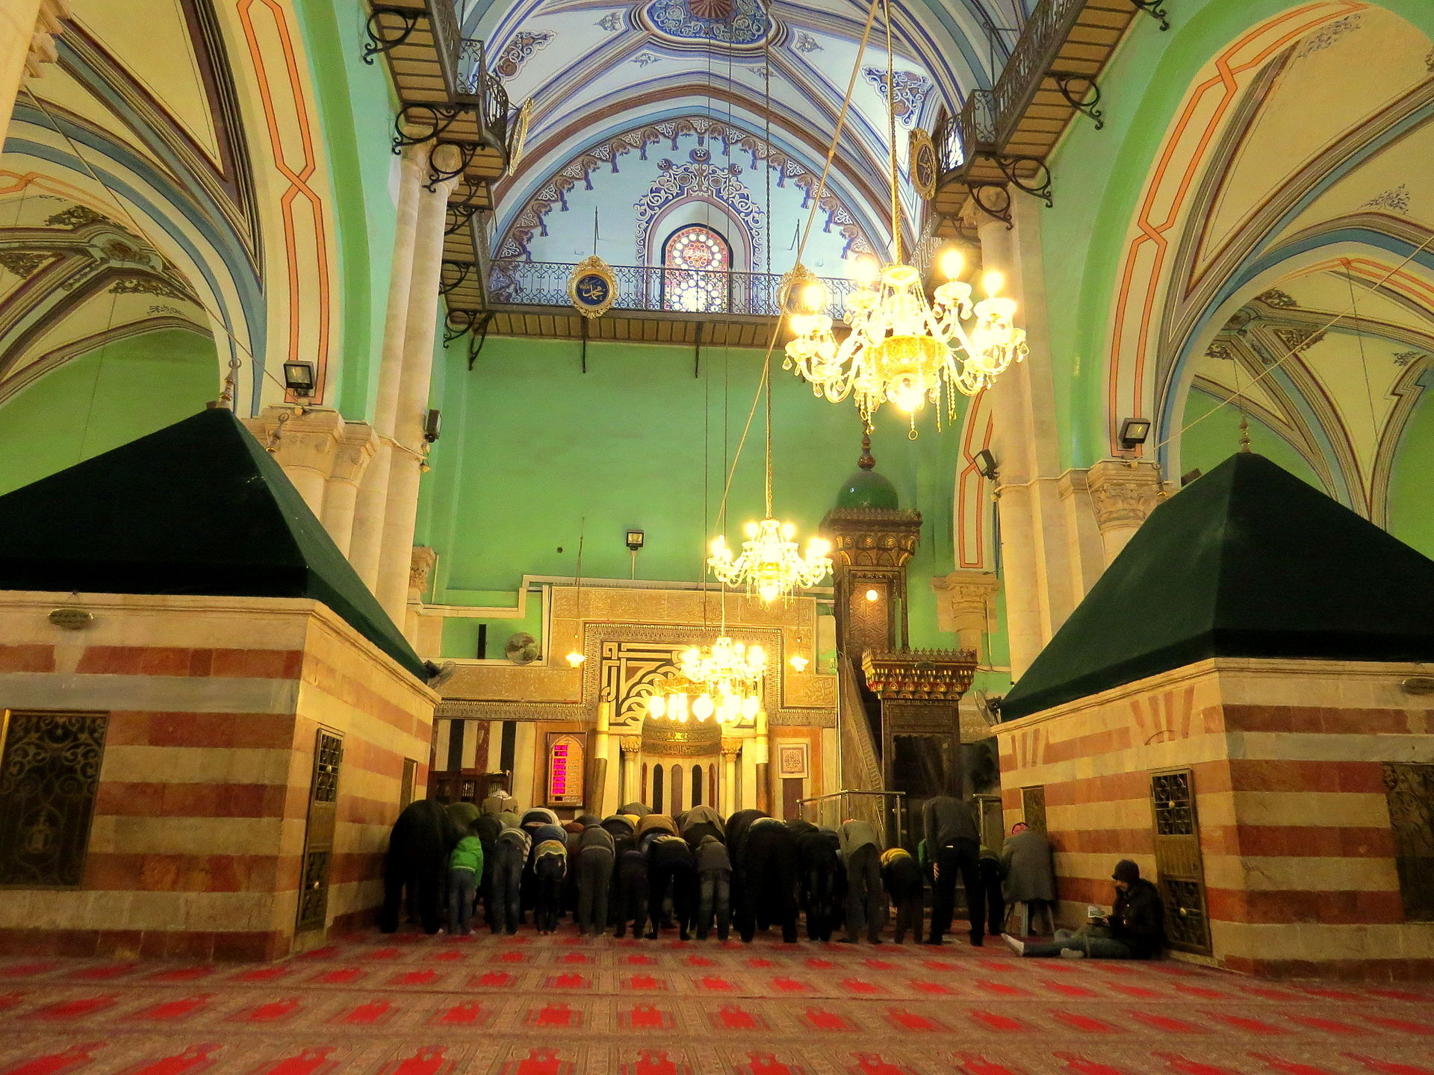
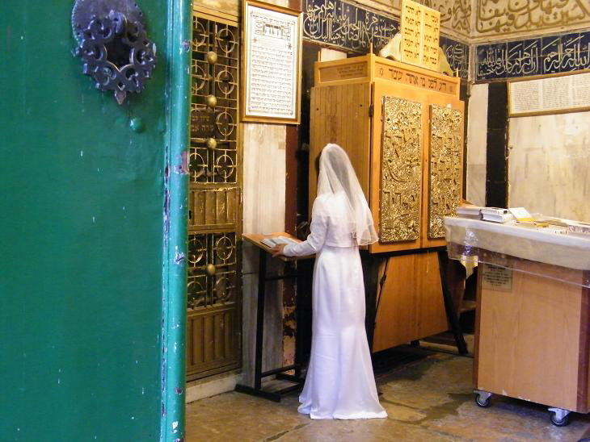
Jewish bride praying at site before her wedding 2010

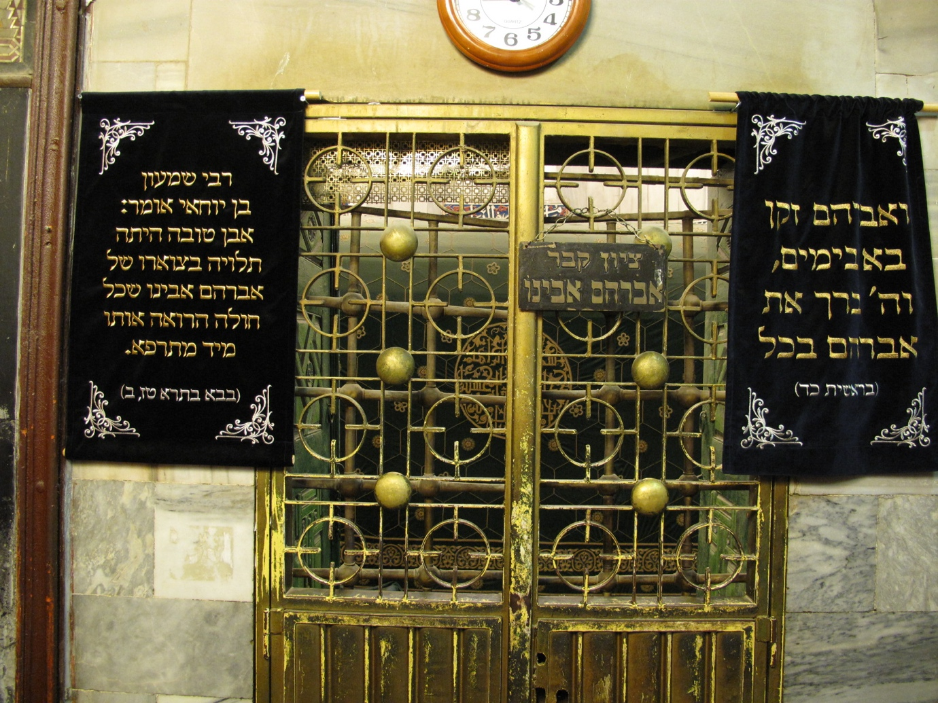
Tomb of abraham

